PolyRestaurant

Realised by

San Wei LEE

IG 3

Index

Part 1 : Projet Specifications ..…………………………………………..3

1.1:  Introduction……………………………………………………………p.3

1.2 : Connections……………………………………………………………p.3

1.3:  Member’s Area………………………………………………………...p.3

1.4   Administrator Page………………………………………………...…..p.5

1.5 System Information……………………………………………………..p.5 1.6 Database Constraints..p.7

Part 2 : Architecture of PolyRestaurant………………………………….9

2.1: Technologies used…………………………………..…………………..p.9

2.2: Structure…………………………………………………..…………….p.9

2.3: Deployment……………………………………….…….……………..p.11

Partie 3 : Conclusion………………………………………………...p.12

1. Projet Specifications

1.1 Introduction

In Asia, food are very cheap and restaurants are everywhere so we never really learn how to cook when we are studying in universities. When I came to France, restaurants on the streets are really expensive and are most of the time for tourist. As I don’t really know how to cook, I often order fast food or some local pizzas for delivery. By doing this, I realize that big franchises such as Dominos Pizza has a great website that allows people to look at the menu and order directly online. Besides, having a website also makes it a lot easier for people like me and other international students who sometimes find it hard to understand French through telephone. This is where the idea of PolyRestaurant came from, the idea of having a user-friendly website to order food for delivery. PolyRestaurant is a website of an asian restaurant where people can easily look at the menu and order food online if they wish to. The menu is separated into 3 categories, which are entrée, plat and dessert. This website also allows you to look at your previous order so that you don’t have to remember what you ordered the next time.

1.2 Connections

Although guests of PolyRestaurant can easily view the menu of the restaurant on the website, users who would like to order online needs to have an account on the website in order to do that. To create an account, it’s easy, users just need to choose a username and password with at least 6 characters, and then fill in personal information such as address and telephone number. Once an account is created, the user can login to enter the member’s area to order food for delivery. This website uses cookies to manage users’ information when navigating through the member’s area.

1.3 Member’s Area

Once entered into the member’s area, users will be able to look at the menu but this time, with the functioning “add to cart” button. Users are now free to choose any entrée, plat and dessert and add to their cart. This time, the table also has 2 extra tabs which are “Mon panier” and “Mes dernieres commandes” which allow users to look at their current basket and their previous order. The “Mon panier” tab will show all food in the current basket and also the total price of the order while the “Mes dernieres commandes” tab will show previous order as well the date ordered. Users can check their personal information by clicking the “Info Personelle” tab on the top of the page. If any users recently moved and would like to change their address or phone number, they can click on the “Modifier Mes Info” tab on top of the page again to easily change their personal information.

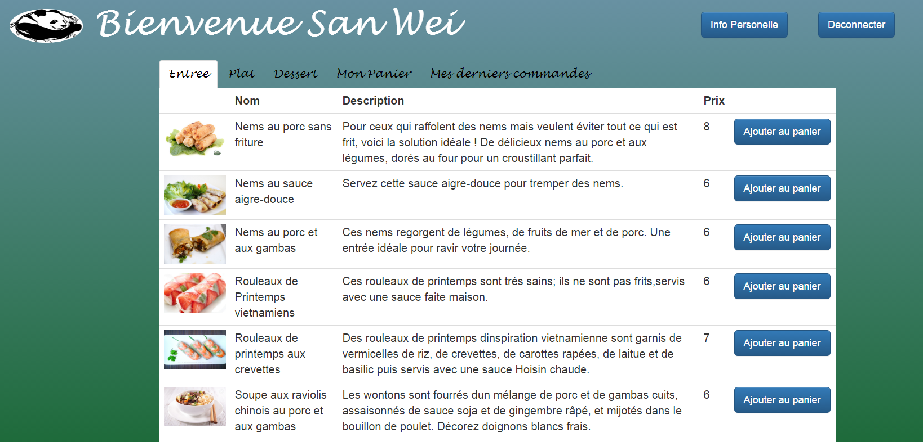

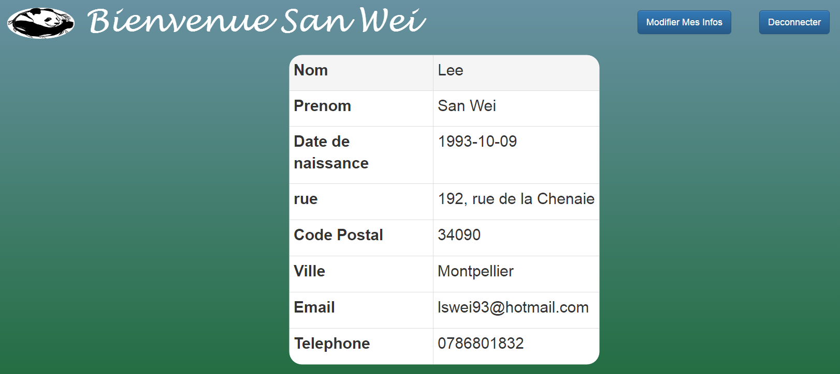

1.4 Administrator page

The owner of PolyRestaurant will of course have an administrator page to manage all orders by each client. In this administrator page, the admin will have the details of all orders, such as the last name of the user, the telephone of the user, the food ordered and also the order date. After preparing the food, the owner can then delete the selected order from the list and continue to deliver their food.

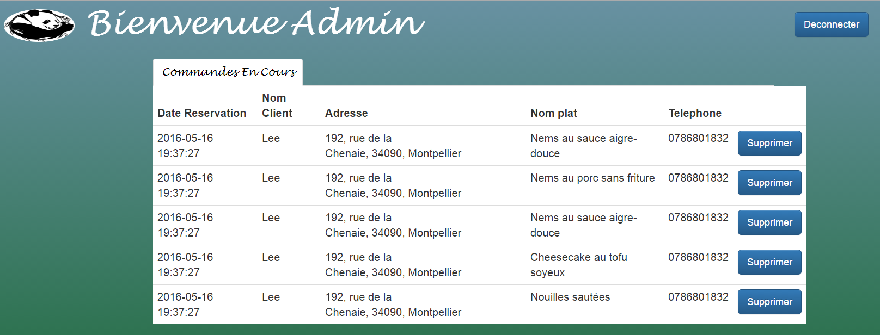

1.5 System Information

1.5.1 Conceptual model of Data

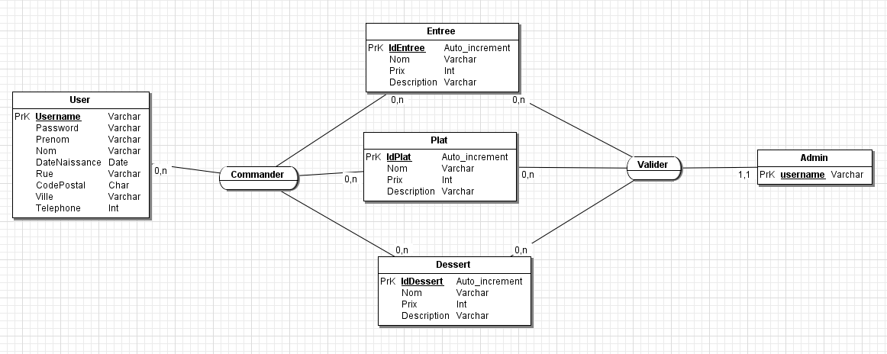

1.5.2 Logical model of Data

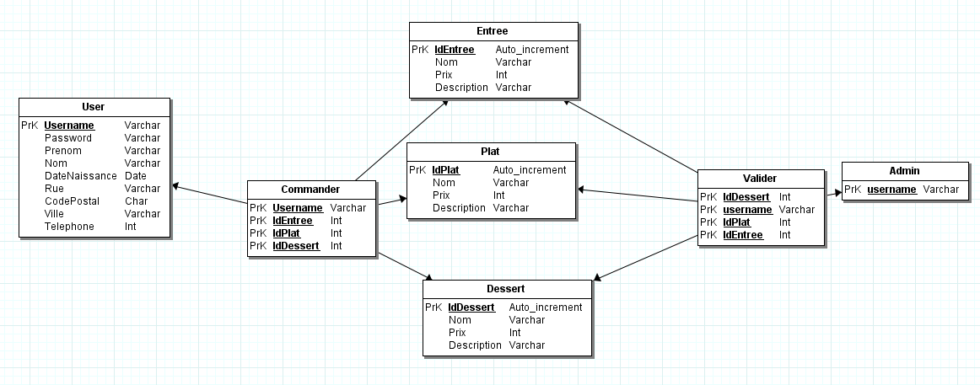

1.6 Database Constraints

Triggers

On this page, triggers are used in the database to facilitate food ordered online

Trigger on the “commandes” table : orders_before_delete

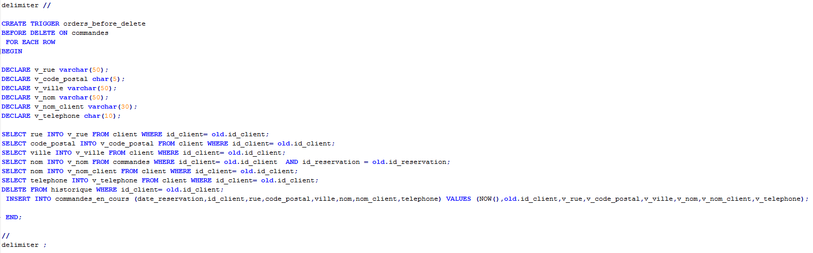

Once a user validate their order, their order will then be deleted on the “commandes” table and it will be then send to the “commandes_en_cours” table so that the admin knows that the order is validated. This trigger automatically inserts the order from the “commandes” table to the “commandes_en_cours” table. It will also automatically delete the “history” table of the current user so that the user gets to see only their previous last order.

Trigger on the “commandes_en_cours” table : history_before_delete

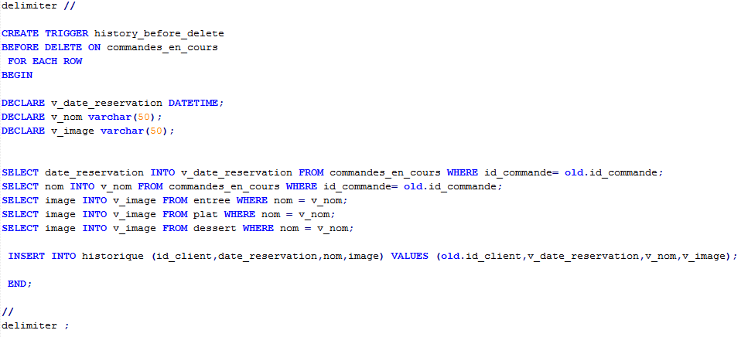Once an order is prepared for delivery, the admin will delete it from the “commandes_en_cours” table and the order will be automatically insert into the history table so that the clients get to see their last order. This trigger does that.

2. Architecture of PolyRestaurant

2.1 Technologies used

For this project, a few web technologies have been used to design, build the website and also to access the database.

* PHP
  + This language is used to script our website server-side. This language is easy to learn and its very useful to build a website with a lot of functions. It also allows us to access our database.
* Bootstrap CSS
  + BootstrapCSS offers a lot of components that are predesigned to design our website. With Bootstrap CSS we do not need to redesigned each components on our website and we can take them directly from the bootstrap component. All we need to do is include the Bootstrap CSS file on our head tag.
* MySQL
  + MySQL is a classic open-source relational database management system. We also used phpMyAdmin to easily manage our database.

2.2 Structure

PolyRestaurant is designed in MVC(model-view-controller), an architectural pattern that separate ways information are presented to or accepted from the user. The model manages directly the data and application, the controller accepts input and converts it to commands for the model or view and the view outputs the representation of the website. MVC is an efficient design that allows website developers to easily maintain or debug a website if any problems exist as the code of each page is separated in 3 ways according to their needs. Below is the schema that represents the hierarchy of PolyRestaurant.

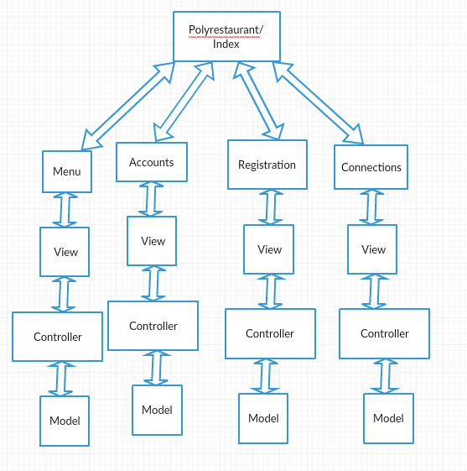

2.3 Deployment

The PolyRestaurant web application is hosted on Openshift with basic free user functionalities. The application consists of PHP 5.4, MySQL 5.5 and phpMyAdmin cartridges.

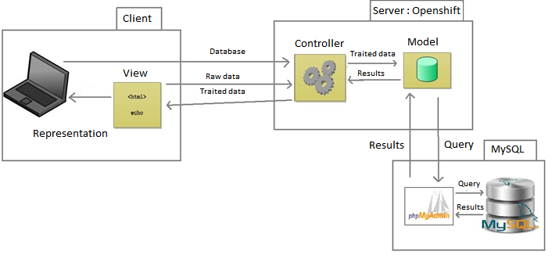

3 Conclusion

Most objectives of this project are accomplished and the site is online and fully functional. The interactions between the site and the database are working smoothly as well. I am also convinced I can use this as a base if I ever want to open a restaurant with delivery services.

With this first web site project I have gained basic needs in developing a web site, especially in web languages such as HTML,CSS,PHP and MySQL. I am now more interested in developing more complex and more secure website thanks to this project. I would also like to learn more about securing cookies on a website.

Although a lot of time is used on learning the PHP language which is new to me, the Bootstrap CSS has saved me a lot of time. I am now more familiar with designing and building a website.

In this project as a whole, I am quite satisfied to be able to finish this project within the given time as I have never learnt web languages before. This project has taught me that I can learn new programming languages mostly by myself and I am now very eager to learn more new programming languages in the future.

Thank you.